**Final Report**

**Software Defined Radio**

**Project Manager: James Bell**

**Samuel Hussey, Zachary Schneiderman**

**Texas State University**

**Ingram School of Engineering**

**SPONSOR Texas State University**

**601 University Drive**

**San Marcos, Texas 78666**

**4/28/2019**



# Overview

## Executive Summary

Texas State University sponsored two computer engineers James Bell, and Zachary Schneiderman, and a Micro-Nano engineer Samuel Hussey to create a low cost, high frequency, single sideband software defined radio.

This project was intended to create a low cost, clear schematic for other students and amateur radio enthusiast to follow to create their own software defined radios. Based on the requirements listed in our test plan we have achieved

*This section should present a clear, concise summary of your project.* ***[3/4 page limit]***

* *who sponsored it,*
* *size of team & mix of major/track,*
* *what your project was intended to do,*
* *how closely you achieved your goals,*
* *in general (concise!) what worked well and what didn't, and briefly summarize which features met design specifications and which did not. Write this section so that if a VP is only going to read one section about whether or not your project worked - this would be the one.*

*NEW PARAGRAPH:Describe the purpose & value of your project. Why did you do it? Who benefitted? How is it of value to your Sponsor/TXST/society/you, etc?*

## Abstract

*Write a concise abstract for your project.* ***[1/4 page limit]***

*THESE SECTIONS ABOVE MUST FIT ON THIS PAGE!!*

From page 2 forward, this document shall have:

* 1” margins all around
* Right-justified or not is your choice
* Times New Roman 12 point (EXCEPT section headers) for text
* 1.15 spacing
* 0 points before, 0 points after
* Use block separation for paragraphs - NOT indentation

Delete this text box once you have understood and obeyed its commands.

Contents

1 Overview 2

1.1 Executive Summary 2

1.2 Abstract 2

2 List of Figures 4

3 List of Tables 4

4 Problem Description 4

5 Progress Towards A Solution 5

5.1 Design Decisions 5

5.2 Design Approach 6

5.3 Project Approach 7

5.4 Engineering Standards 8

5.5 Progress Towards Goals 8

5.6 Verification 8

5.7 Characterization Results 8

5.8 Deficiencies 9

5.9 Iterations and Redefinitions 9

6 Constraints 9

6.1 Budgetary 9

6.2 Design Feasibility 9

6.3 Manufacturability 10

6.4 Maintainability 10

6.5 Environmental 11

6.6 Health and Safety 11

6.7 Social 11

7 Budgets 11

8 Work Schedule 14

9 Personnel Interactions 14

9.1 Teamwork 14

9.2 Mentorship 14

10 Ethics 15

11 Summary & Conclusions 15

12 Discussion 15

12.1 Academic Preparation 15

12.2 Lessons Learned 15

12.3 Soft Skills 15

12.4 Schedule Deviations 15

12.5 Staffing 15

12.6 Final Observations 15

13 Acknowledgments 15

14 References 16

# List of Figures

# List of Tables

# Problem Description

Most software defined radio transceivers on the market are $300 or more. Our project is to create a cheaper alternative that facilitates understanding and learning through the user constructing it themselves.

Our project deliverables are:

* Have an on off power switch with LED indicator
* Receiving single sideband on the 20m and 80m north American amateur radio bands
* Convert received single sideband signal to audio signal
* Take in audio signals and converting that to single sideband
* Taking said single sideband audio signal and transmitting it on the 20m and 80m north American amateur radio bands
* Show the currently tuned to frequency, sideband, selected license level, and band of operation on a screen
* Run on standard US power
* Total unit cost to be under $300
* Volume control for speaker

This is the latest basic design we came up with after many hours of research and some trial and error:

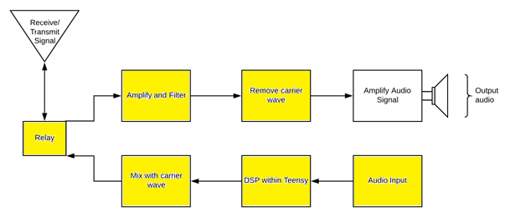

Figure : Top Level Diagram, Yellow Is what we have done ourselves

# Progress Towards A Solution

## Design Decisions

Here was the first ever top-level design: 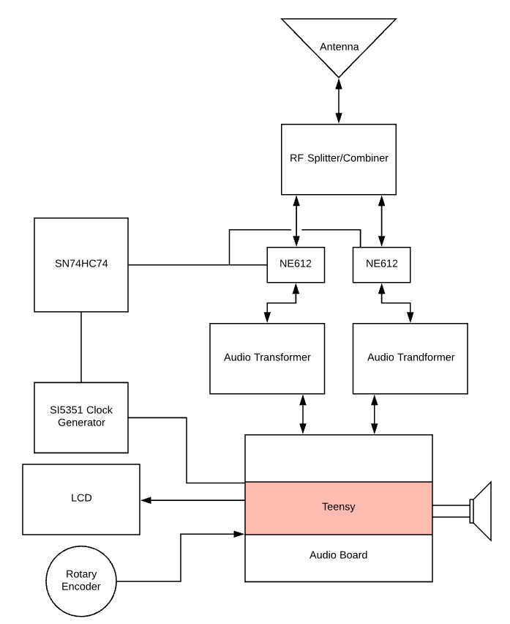

Figure : First ever top level design for system.

A close up of a logo

Description generated with very high confidence

Figure : Latest Overall design of system. No color

As one can tell figure 2 and figure 3 are very different in both clarity and design. Some of

The key changes I will list below and why they were done.

* The Teensy no longer sees the received signals directly. This was done to isolate the very sensitive Teensy from possible voltage spikes received in the system. Reducing the chances, the Teensy will be damaged or destroyed.
* The Audio isolation transformers were removed, as they seemed to only degrade and distort the signal sent to them.
* A relay was introduced to separate the transmit and receive to reduce the chances of feedback in the system. If feedback from transmit was taken in to the RF amplifier and amplified it is possible the amplifier would have a catastrophic failure.
* The SN74HC74 D-flip flops were removed as we discovered the clock generator could perform the same function. This makes the device simpler in hardware and cheaper as those parts are no longer needed.
* The position of the RF splitter and combiner had to be broken in to 2 places. One Combiner after the “Mix with carrier wave” block and one splitter at the “Remove Carrier wave” block in figure 3. As this was useful for splitting and combining the signals only at the needed locations reducing cross talk in the system by reducing the number of RF wires in the system.

## Design Approach

Our initial design is based on Charlie Morris’s software defined radio project posted online. First, we wanted to simulate the design as best as possible. Our most accessible tool for simulating the analog components was and is the free circuit modeling software LTspice. Here is the 80m bandpass filter designed in LTSpice.

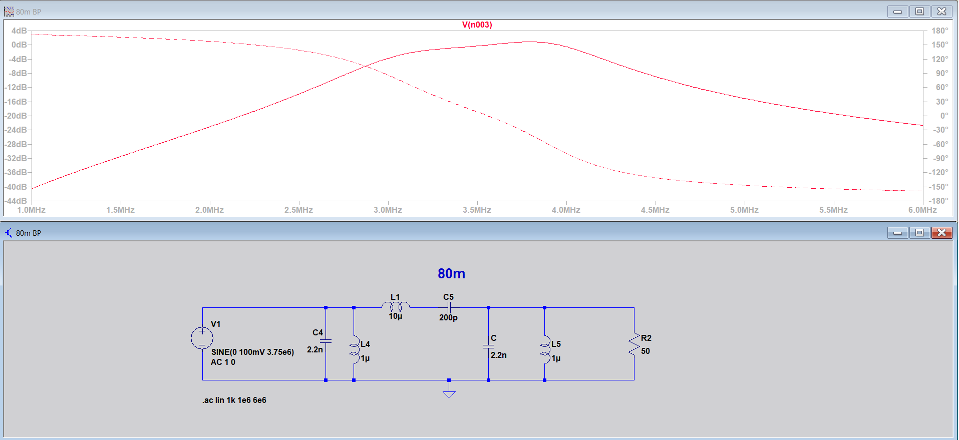

After modeling the analog components, we could, we tested everything we could including the off the shelf components with the tools on the work benches in Ingram 2107. These tools are Keysight, 334460A digital multimeter, InfiniiVision MSOX4054A mixed signal oscilloscope, 33600A series waveform generator and the E36311A power supply.

## Project Approach

The project was organized and subdivided primarily on the Weekly Project Schedule. This

was updated every week at the time of writing out the weekly report. In this schedule each

member of the team was assigned a task, given a start date, due date, the the number of days between the two dates and the status of the project. This allowed us to keep track of who was doing what, when it was due, if it had been completed and discus if the length of time given was or had been adequate for the assigned task.

The first series of tasks included research in to radios, meaning how they were often constructed, operated and used. In other words, establishing for us the fundamentals of radio development and operation to set our goals and deliverables against.

For the second step we looked in to a pre-existing Software defined radio project posted online by Charlie Morris. This individuals design gave us a good starting place to work from.

From there we began simulating and modifying analog components for the north American radio frequency range, working on replacements such as an off the shelf audio amplifier instead of his home made one for simplicity, and establishing software-controlled relays instead of his manual ones.

Step 4 was to start building the analog components and ordering the off the shelf components, this was done so that the analog components would be done about the same time the off the shelf components came in.

Step 5 was testing all the components individually and slowly integrating them as a system. Once a component was tested to our satisfaction, we integrated it with another component creating a hierarchy of sub-systems. Each being tested as we went.

Step 6 included correcting found deficiencies from step 5 and creating the code for the receiving side of the radio as it is arguably the most important half of a radio.

Step 7 saw the beginning of reception tests and generating of test signals such as single sideband modulated music signals to be sent in to the radio and demodulated.

Step 8 is the transmit side of the radio, this is where we add the microphone, necessary Digital signal processing code, and begin transmitting testing of the radio. After correcting system deficiencies, the system will be complete.

## Engineering Standards

|  |  |  |  |
| --- | --- | --- | --- |
| **Standard** | **Title** | **Application** | **Relevance** |
| I2C | Inter-Integrated Circuit | Used between the Teensy, Clock generator, and LCD screen | Inter-circuit communications |
| FCC, Radio Frequency Devices | 15.5 General conditions of operation | This is the category of FCC regulation our radio falls under and the guidelines it must follow. | Radio transmit legality |
| International Telecommunication Union - J3E | single sideband suppressed-carrier | Limit of 3000Hz bandwidth for transmit | Standardization of transmit side of radio. |

## Progress Towards Goals

To date, we have completed all but one of our proposed deliverables. The transceiver currently: has a power board supplying all components with their recommended power, has gain of 18 and 12 on the 80m and 20m bands respectively, has an on/off switch with an indicating LED, can receive and demodulate SSB signals on the 80m and 20m bands and those bands only, operates in real time (defined as under 100ms), has an implemented rotary encoder and corresponding display as well as volume control on the audio amplifier. Currently, the transmit portion is not functional. Though all of the analog components are in place, implementing the microphone and configuring the code in order to process the signal has proved time consuming, so the decision was made to focus on other portions of the project.

*Clearly indicate your progress toward achieving your proposed deliverables. If there was any change in your deliverables from those originally proposed, explain the reasons and provide justifications.*

## Verification

The majority of the testing was done with the available lab equipment, which proved more than adequate for the technical specifications we were looking to verify. The oscilloscopes and digital multimeters were used to probed various points of the transceiver in order to follow the signal through the analog components and verify its form and magnitude with expected values, as well as produce bode plots that confirmed the transceiver’s operable regions. The one technical test that did not utilize the lab equipment was the volume control. In order to confirm a variable volume within an acceptable range, a decibel meter application was used to measure the ambient noise levels in a room before the radio was turned on. Then, the volume was slowly turned up until it reached maximum volume at which point the decibel meter was used to again measure the noise levels near the speaker.

*How exactly did you verify/confirm you met your technical goals? Describe the test bed you constructed or used, and how many samples you tested (if applicable).*

## Characterization Results

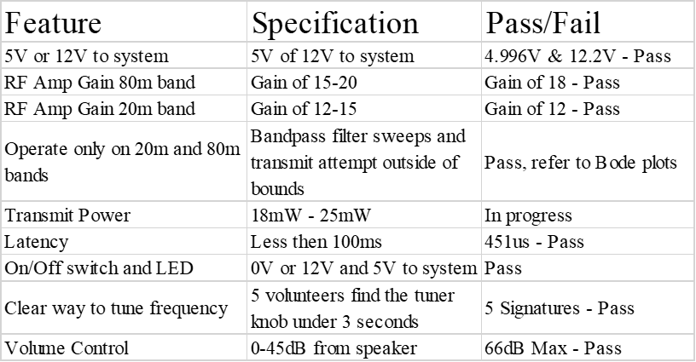

*Show a* ***concise*** *table listing each Test Case, its corresponding specification(s), the results of the test, and whether or not it was compliant with the specification.*

## Deficiencies

*For each deficiency, address the effect on system performance and design. Include any estimates of time and effort required for correction of each deficiency and any recommendations regarding the urgency of each correction, and the recommended solution or approach to correcting deficiencies.*

*Summarize in a table.*

## Iterations and Redefinitions

*Reproduce your project definition from the SOW. Now, contrast this with what you had as your project definition at the time of writing this report by answering the following IN DETAIL.*

*Describe each relevant/major iteration or redefinition. How or why did they occur? What were the circumstances? Roughly when did it occur? What was the impact? What did you learn from it?*

# Constraints

## Budgetary

Our limit was self-imposed by researching other premade high frequency software defined radio transceivers on the market. As most of them are around $300 we wanted to be under $300 with as much of the radio directly related to the radio frequency operations made by hand to facilitate learning about radio frequency components.

Thankfully the desire to make as much of the radio frequency components by hand has made this design much cheaper then it would otherwise have been. A lot of the pre-built bandpass filters and amplifiers are $20 or $30 a piece whereas the homemade ones are at most a $1. The current total of the radio is $146.20.

## Design Feasibility

As students at Texas State University we have access to some of the best test bench equipment on the market and a good deal of very advanced and useful modeling software. Unfortunately, most of this equipment and software was as new as the Ingram building and we were not given much in the way of training with these new tools as we were no longer in the classes where that training was being given.

As a result we stuck to modeling software we knew well like LTspice and focused on learning the hardware testing tools available to us like the new oscilloscopes as we understood that simulations are often different from real world responses especially with high frequency radio designs.

The hardest things to test in our design are the toroid’s as we did not have the tools to characterize them easily. As these are only radio frequency splitter and combiner, we overcame this with a simple test. We ran a sinusoidal input to the toroid and read the outputs on 2 oscilloscope inputs, if the signals on the 2 outputs matched the input signal, we had success. This of course made testing these components more prone to error then many of our other components, but we discovered near perfect signal coupling from 2Hz all the way to 20MHz. This could easily change due to how the toroid is wrapped making recreating this component more prone to error then others in the system. We can only provide details on how to do this for others and hope for a good result.

Outside of the toroid’s the testing another big hurtle was the transmit and receive full system tests. This required us to create single sideband signals in Matlab, convert them to .csv, import them in to the function waveform generator as arbitrary waveforms, modulate them with the carrier wave and see if the audio was as expected. The transmit testing was even more complicated as it required us to record the signal on the oscilloscope and then feed it back in to the system on the wave form generator as an arbitrary wave file and see if the audio is what was input initially. This was a very labor intensive process as we had to learn all the intricacies of the new test bench tools we had available but was doable.

Now as this is a project for students and others whom may not have much money to spend on radios or other electronics equipment our goal was to create a pin by pin schematic so that those following the schematic do not need equipment like we have available to us here.

## Manufacturability

To manufacture this device, we only required a soldering station, and perf-boards to solder the components and establish wire connections to said components. The box could require the use of any tools ranging from a 3d printer to a drill and hammer as it is only a box for safety.

For our project we used a hand drill, sandpaper, a soldering iron, perf-board, solder, a cigar box and a dermal with a wood cutting bit to make our enclosure and the entire device. This was intentional as we did not know if we were going to have access to the makerspace and as this is for students and others whom may not have more then a basic tool set on hand it could be recreated by anyone with said basic tools.

## Maintainability

For the software versions of the software will be available online by version of schematic. Meaning schematic, one will correspond to version one of the software. As more versions are added the code and schematics will be updated as needed with references to the corresponding code or schematics.

This is as close to maintenance we get as our device will be built by, modified by, and cared for by the end user.

## Environmental

This project is environmentally friendly because it requires only the minimum things needed to operate in the most popular way on 20m and 80m bands. In addition, by building this in house with our schematics it does not need the many hours of extensive FCC testing, and regulation compliance testing required to sell the radio commercially, reducing its overall carbon footprint.

## Health and Safety

A big concern for us is the possibility of being shocked as this is to be built by someone at home. Therefore, we designed our device to include an off the shelf power supply and not include a transmit power amplifier as those are the two most dangerous areas for voltage and current.

## Social

A radio is inherently a social tool. Due to this fact we wanted our radio to allow the greatest number of users to reach the greatest number of people. After talking with our sponsor, we concluded the best high frequency bands and modulation type to facilitate communications on our radio were the 20m and 80m amateur radio bands and the single sideband modulation type.

Another key element to this is that this device is intended for learning. As a result we wanted the user to be able to select their license level and in tern limit the transit functionality to the license level selected as this will reduce the chances of improperly transmitting.

# Budgets

|  |  |  |  |  |  |  |  |
| --- | --- | --- | --- | --- | --- | --- | --- |
| **SDR Parts List** | | | | | | | |
| Section | Name | Quantity | Description | Cost Per-Unit | Cost Per-Item | Proposed budget | |
| Base |  |  |  |  |  |  | $300.00 |
|  | Teensy 3.6 | 1 | Microcontroller | $30.00 | $30.00 |  |  |
|  | Audio Shield for Teensy | 1 | Audio Adapter for Teensy | $15.00 | $15.00 |  |  |
|  | Rotary Encoder with Push button | 1 | Used to pick signal | $6.00 | $6.00 |  |  |
|  | LCD | 1 | Freq Display | $ 8.00 | $8.00 |  |  |
|  | I2C adaptor for LCD screen | 1 | For interfacing the LCD and the Teensy | $1.50 | $1.50 |  |  |
|  | Si 5351 Breakout | 1 | Clock Gen Shield by AdaFruit | $8.00 | $8.00 |  |  |
|  | 100nF Cap | 3 |  | $0.02 | $1.00 |  |  |
|  | 10kOhm Res | 2 |  | $0.02 | $1.00 |  |  |
|  | Perf Boards | 1 | Ample Real Estate | $5.00 | $5.00 |  |  |
|  | 22+ Gauge Wire | 1 |  | $5.00 | $5.00 |  |  |
|  | Relays | 3 | G5LE-1-E-36-DC5 | $2.50 | $7.50 |  |  |
|  | Magnetic 32 Gauge wire | 1 | used to wrap toroid cores | $5.00 | $5.00 |  |  |
|  | 12V wall outlet | 1 | Main Power supply | $10.00 | $10.00 |  |  |
|  | Barrel Jack Plug |  | Comes with power supply | $ - | $0.00 |  |  |
|  | 5V Voltage Regulator | 2 | 12v to 5v converter | $1.00 | $2.00 |  |  |
|  | Variable Voltage Regulator | 1 | LM317T variable voltage regulator | $1.00 | $1.00 |  |  |
|  | FT50-43 Core | 1 | Bifilar toroid Core (8T:8T) | $0.75 | $0.75 |  |  |
|  |  |  |  |  |  |  |  |
| 80m BandPass Filter |  |  |  |  |  |  |  |
|  | 2.2nF Capacitor | 2 |  | $0.02 | $0.04 |  |  |
|  | 200pF Capacitor | 1 |  | $0.02 | $0.02 |  |  |
|  | 1uH Inductor | 2 |  | $0.02 | $0.04 |  |  |
|  | 10uH Inductor | 1 |  | $0.02 | $0.02 |  |  |
|  |  |  |  |  |  |  |  |
| 20m BandPass Filter |  |  |  |  | $0.00 |  |  |
|  | 492pF Capacitor | 2 |  | $0.02 | $0.04 |  |  |
|  | Variable Capacitor | 1 |  | $0.02 | $0.02 |  |  |
|  | 0.32uH Inductor | 2 |  | $0.02 | $0.04 |  |  |
|  | 2.67uH Inductor | 1 |  | $0.02 | $0.02 |  |  |
|  |  |  |  |  |  |  |  |
| Radio Frequency Amplifier |  |  |  |  |  |  |  |
|  | 10nF Capacitor | 1 |  | $0.02 | $0.02 |  |  |
|  | 100nF Capacitor | 3 |  | $0.02 | $0.06 |  |  |
|  | 100Ohm Resistor | 1 |  | $0.02 | $0.02 |  |  |
|  | 2kOhm Resistor | 1 |  | $0.02 | $0.02 |  |  |
|  | 10kOhm Resistor | 2 |  | $0.02 | $0.04 |  |  |
|  | 2.2k Ohm Resistor | 1 |  | $0.02 | $0.02 |  |  |
|  | 2N3904 Transistor | 1 |  | $0.50 | $0.50 |  |  |
|  | 1mH Inductor | 1 |  | $0.02 | $0.02 |  |  |
|  |  |  |  |  |  |  |  |
| DC Receiver Frontend |  |  |  |  | $0.00 |  |  |
|  | SA612 | 2 | Audio Mixer and Oscillator | $2.50 | $5.00 |  |  |
|  | 8 pin socket | 2 |  | $0.25 | $0.50 |  |  |
|  | FT50-43 Core | 1 | Bifilar toroid Core (8T:8T) | $0.75 | $0.75 |  |  |
|  | 100nF Cap | 5 |  | $0.02 | $0.10 |  |  |
|  | 1uF Cap | 2 |  | $0.02 | $0.04 |  |  |
|  | 6.8uH Inductor | 2 |  | $0.02 | $0.04 |  |  |
|  | 1mH Inductor | 2 |  | $0.02 | $0.04 |  |  |
|  | 4.7kOhm Resistor | 2 |  | $0.02 | $0.04 |  |  |
|  |  |  |  |  |  |  |  |
| Audio Amplifier | Audio Amplifier | 1 |  | $15.00 | $15.00 |  |  |
| Speaker | 4 Ohm Speaker | 1 |  | $5.00 | $5.00 |  |  |
| Push to talk Mic | Microphone for transmit | 1 |  | $12.00 | $12.00 |  |  |
|  |  |  |  |  |  | Difference between | |
|  |  |  | Total Cost Before Shipping | | $146.20 | $153.80 | $ 300.00 |

This project did not have a proposed budget, only a limit and a parts list defining costs. I

Included the parts list above with the limit vs the total spent. We are $153.80 under our limit for this project.

# Work Schedule

*The schedule section must make clear to the readers which tasks were completed and which were not. Wherever possible make it clear which team member(s) were responsible for each* ***major*** *task. Discuss any timeline changes since the proposal was submitted. Use Gantt charting techniques (or side by side table if it’s preferable) to show the current status of the tasks in relation to the proposed schedule. However you do this it has to be readable!!! It will be a Figure or Table.*

# Personnel Interactions

## Teamwork

*The teamwork section must clearly and concisely state the responsibilities of*

*each team member and his/her contribution to the senior design project. This is an expansion of Section 8. You can convey this information in a method of your choice, i.e. text, table, etc.*

## Mentorship

*What role did your Technical Mentor (Sponsor) and Faculty Advisor play? How much time did you spend with them and how frequently? How much did they assist you? What did they do? (point you towards resources, chalkboard lectures, help solve problems when stuck, etc) Be specific and give examples whenever possible.*

You're tiptoeing on political turf here so be very careful how you word this. If you got very little mentorship from your Sponsor/Tech Mentor then perhaps they did a great job defining the project, pointing you in the right direction, asking pointed questions, etc.

# Ethics

*You must discuss the ethics associated with your project. Treat this like your Ethics Paper - write an analytical (NOT persuasive or opinion) essay. Use moral & ethical theories & principles as appropriate as you did in your Ethics Paper. Include elements of IEEE & NSPE codes of ethics as you did in your Ethics Paper.*

# Summary & Conclusions

*Describe the overall capabilities and deficiencies of the system. (This is the more technical and detailed version, which you will summarize for the Executive Summary.) Provide a statement, based on the results of the system or module test, concerning the adequacy of the system or module to meet project requirements. How close did you come to your objectives?*

# Discussion

## Academic Preparation

*Were your TXST EE courses useful preparation for your project? How much, and if yes, how? If not, why not? If not, what resources were used?*

## Lessons Learned

*What did you learn about the engineering process? Teamwork? Management?*

## Soft Skills

*What soft skills did you develop, improve or learn that you did not have before taking Senior Design? What elements of the course, or activities or assignments facilitated this learning?*

## Schedule Deviations

*What caused any deviation? What could you have done to better stay on track? What elements were under your control? Out of your control?*

## Staffing

*Was your project adequately/correctly staffed? Why or why not? Enough members? Right major/tracks?*

## Final Observations

*If you had this project to do over again, what would you have done differently?*

# Acknowledgments

*Briefly acknowledge the individuals who helped you technically, organizationally, etc.*

*At a minimum you must acknowledge your Sponsor and your Faculty Advisor. Be generous!*

# References

*List relevant references. This section provides a bibliography of key project references and deliverables. This should not be a long section, but should show that you referenced and followed applicable guidelines.*